Program No.01:

CODE:
<html>
<head>
<title>First web page</title>
</head>
<body>
<h1>HELLO! My name is </h1>
<h1><a href="https://www.linkedin.com/in/not-darshil-kumar/">Darshil</a></h1>
<h2>I am a second year student</h2>
<p>This is first program of this lab and this program includes hyperlink,head,title,body,paragraph tags.</p>
</body>
</html>

OUTPUT:
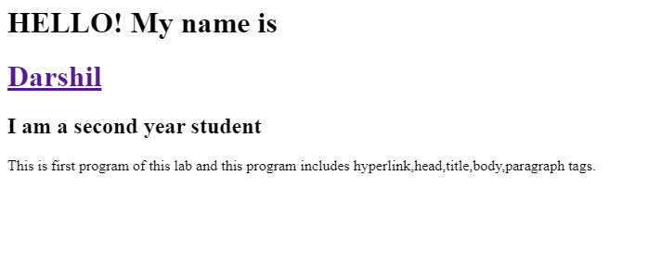

Program No.02:

CODE:
<html>
<head>
<title>second web page</title>
</head>
<body>
<h2>HEllO! My name is <a href="https://www.linkedin.com/in/not-darshil-kumar/">Darshil</a></h2>
<h2></h2>
<h2>I am a second year student</h2>
<p>This is second program of this lab and this program includes bold,italic,underline,subscript,supercript and images tags.</p>
<p>This is for <b>Bold</b> Tag</p>
<p>This is for <i>Italic</i> Tag</p>
<p>This is for <u>Underline</u> Tag</p>
<p>This is for <sub>Sub Script</sub> Tag</p>
<p>This is for <sup>Super Script</sup> Tag</p>
<img src="\images\bg.png" alt="Background" width="1530" height="1200">

</body>
</html>

OUTPUT:
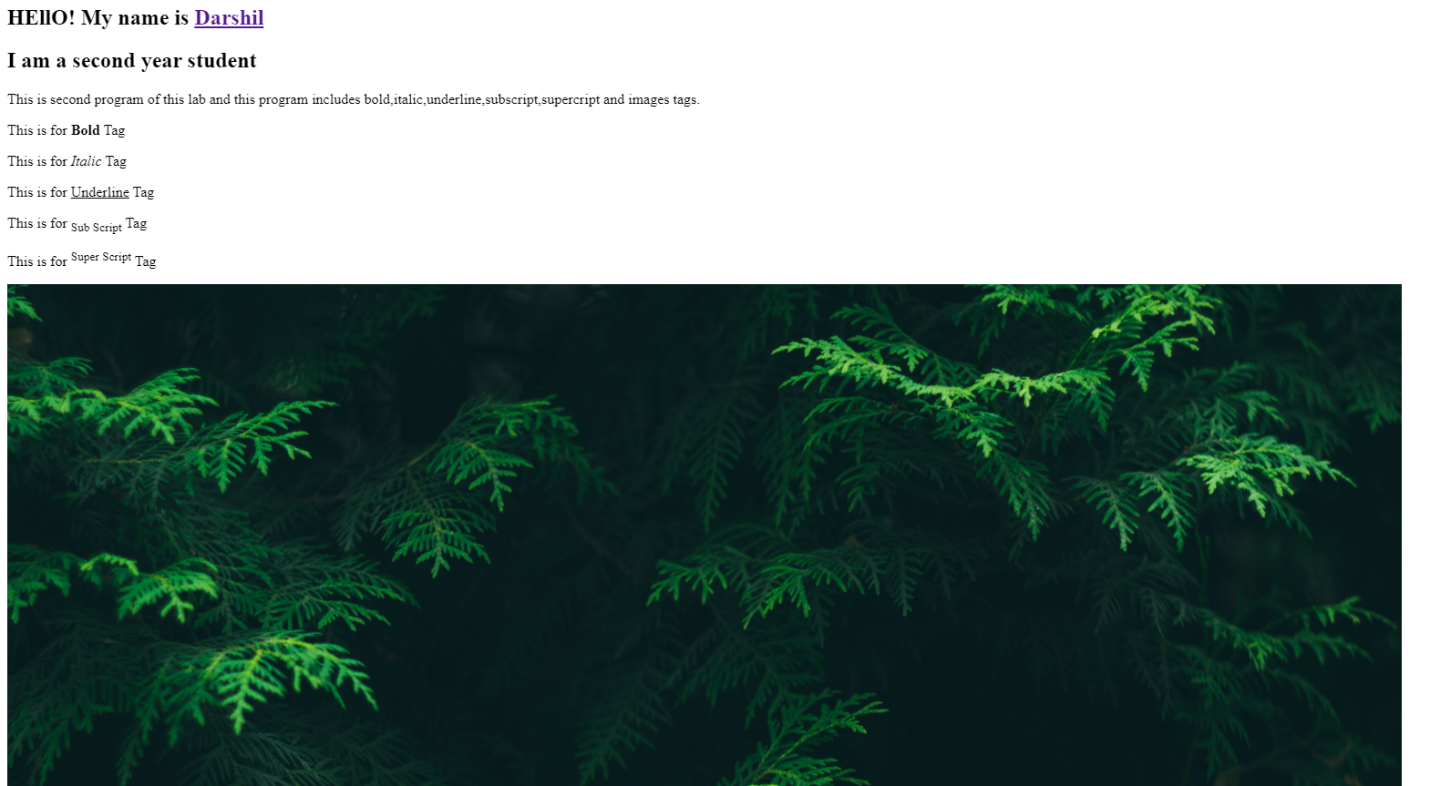

Program No.03:

CODE:
<html>
<head>
<title>third web page</title>
</head>
<body>
<h2>Welcome!</h2>
</p>This is Web designing lab and this is program 3 </p>
</p>This is Web designing lab and this is program 3 </p>
<hrx>
<hr>
<h2>HTML</h2>
<p>The HyperText Markup Language or HTML is the standard markup language for documents designed to be displayed in a web browser. It defines the meaning and structure of web content. It is often assisted by technologies such as Cascading Style Sheets and scripting languages such as JavaScript.</p>
</p><a href="https://en.wikipedia.org/wiki/HTML">More</a></p>
<hr>
<h2>CSS</h2>
<p>Cascading Style Sheets is a style sheet language used for describing the presentation of a document written in a markup language such as HTML or XML. CSS is a cornerstone technology of the World Wide Web, alongside HTML and JavaScript.</p>
</p><a href="https://en.wikipedia.org/wiki/CSS">More</a></p>
<hr>

<h2>JavaScript</h2>
<p>The HyperText Markup Language or HTML is the standard markup language for documents designed to be displayed in a web browser. It defines the meaning and structure of web content. It is often assisted by technologies such as Cascading Style Sheets and scripting languages such as JavaScript.</p>
</p><a href="https://en.wikipedia.org/wiki/HTML">More</a></p>
<hr>

</body>
</html>

OUTPUT:
